**R Code for Examples in the book**

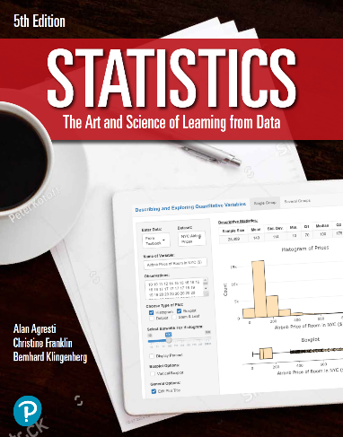

***“Statistics: The Art and Science of Learning from Data”***

**by Agresti, Franklin and Klingenberg, 5th edition**

**Chapter 11**

**Example 11: Hero or Criminal – Permutation Test**

## Reading in data

mytable <- as.table(matrix(c(1, 9, 2, 5, 2, 1), nrow = 2, byrow = TRUE,   
 dimnames = list(Status = c('U.S.',   
 'International'),  
 Opinion = c('Hero',   
 'Criminal',   
 'Neither'))))  
mytable # viewing the table

## Opinion  
## Status Hero Criminal Neither  
## U.S. 1 9 2  
## International 5 2 1

## To perform a permutation test with 10,000 random permutations

chisq.test(mytable, simulate.p.value = TRUE, B = 10000)

##   
## Pearson's Chi-squared test with simulated p-value (based on 10000  
## replicates)  
##   
## data: mytable  
## X-squared = 6.9318, df = NA, p-value = 0.0341